My original idea was my hands creating a clay elephant and the world around it piece by piece. Then the elephant would get lonely and I would try to cheer it up. Then I would destroy the world to make a baby for the elephant. The idea I choose was not really that similar except for concept. The idea I choose was an elephant builds itself out of clay and then accidently rolls over a snake eggs. The snake becomes sad and the elephant try to cheer up the snake. The elephant cannot cheer up the snake so it uses it body to make baby snakes for the snake. The reason for this change was not being able to use my hands and film and it will take more time to do an animation of that quality.
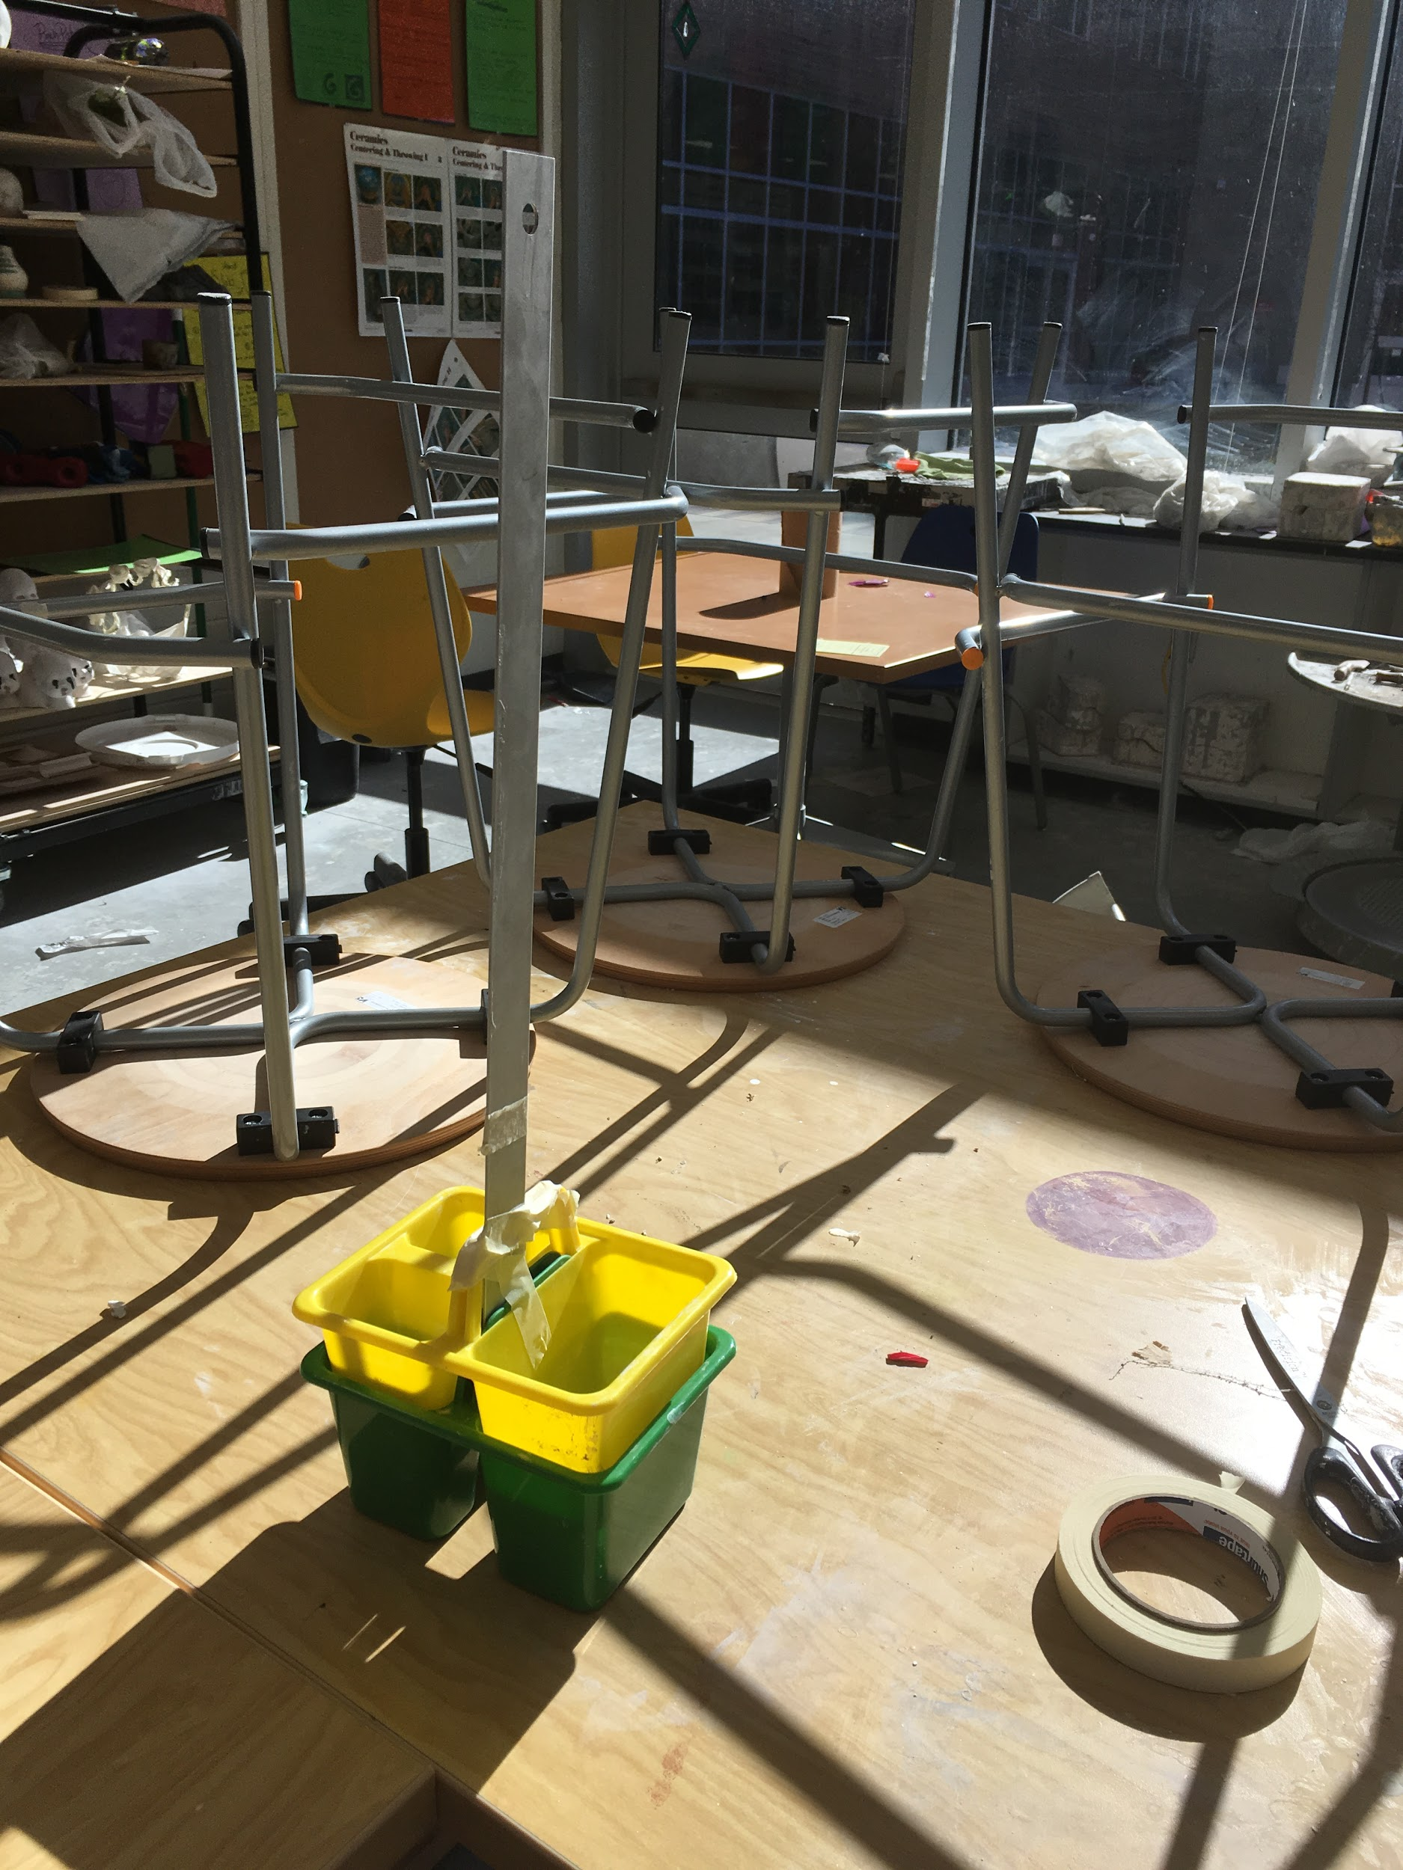
I made this animation by using the app Stop Motion to take pictures or frames and put them together to create an animation. I used clay to make the actual characters and used some tape, a ruler, and a pencil case thing to make a stand for my phone so it can take pictures for the claymation.

The most difficult things for me during this process was using clay for the characters and lighting consistency. The clay dried up very fast, cracked and crumbled, and was hard to manage. Those are some of the reasons why clay was difficult to work with and at times made me somewhat frustrated with it not cooperating. Also I had to film this over the course of 3-4 days so the lighting changed a lot each day, so when I filmed it the animation looked a little inconsistent.

I found the part with the elephant morphing into a ball to be the successful part of my animation. The reason I found this most successful was I felt the transformation was very fluid and smooth.

I spent the most time on the filming and moving of the models into position for each frame. But I did spend a lot of time on the making of each character. I feel like I spent the least time on making and drawing out the story, I just sort of went with the flow because I already had a basic story in my head.

Some of the Principles of Animation I used were squash and stretch when I morphed the elephant into a ball and it moved, anticipation when the elephant accidentally ran over the snakes eggs, slow in and slow out when the elephant started moving as ball. Then appeal because I felt like the characters were simple yet expressenate and charming at the same time. Timing, I used more frames to create solower actions when the elephant turned into a ball to emphasize what was happening. I also used exaggeration to make the whole animation feel more cartoony especially with the character’s appearance.
I feel like I learned a lot about animation during the assignment. I learned that animation takes a long time to be quality and that you need a lot of time and patience for it. I also learned to probably not use clay for another claymation because of just how dried up it can get. Then I learned what it takes to make an animation and how to make a successful animation via The Principles of Animation. Lastly I learned I need to be more patient and dedicated if I want to produce a successful quality animation.

